MYSQL ASSIGNMENT – HARSHINI PRASANNA

1. create an database called company:
Query: create database snap_route ;
Output
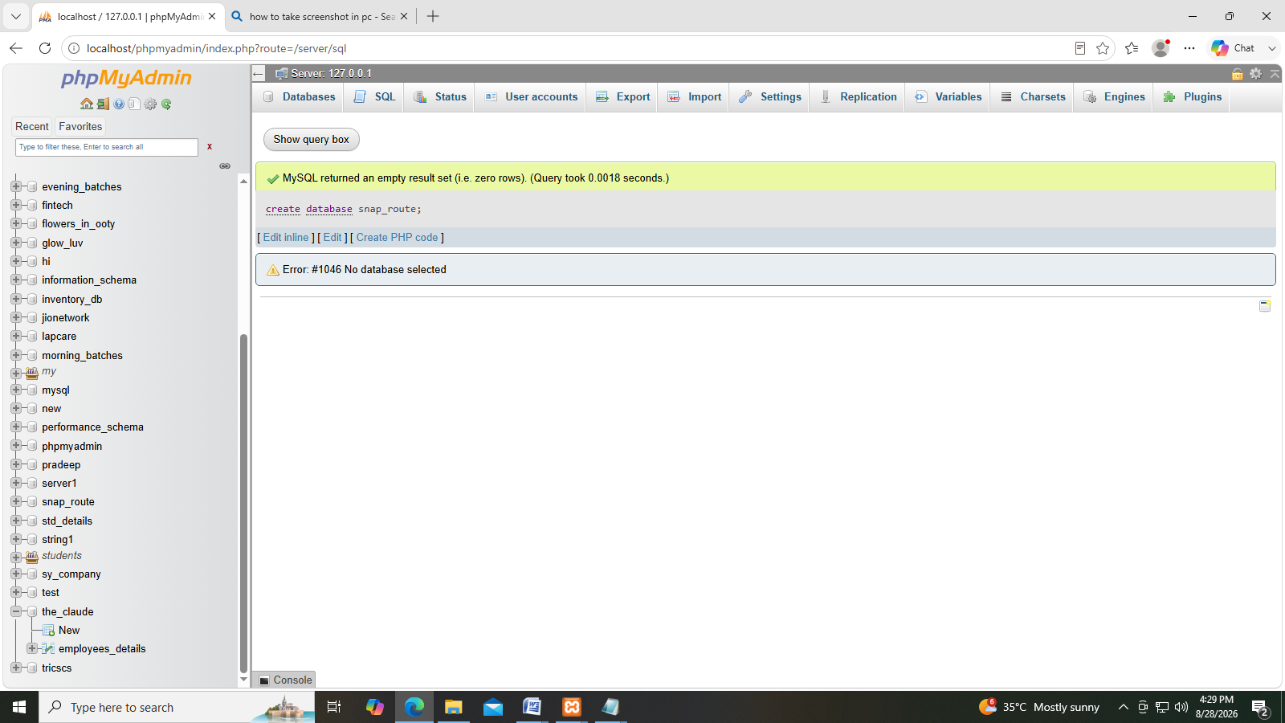

2.create an table called Employees id, name,age,salary,department.
Query: create table employees(id int, name varchar(30), age int, salary int, department varchar(30));
Output:
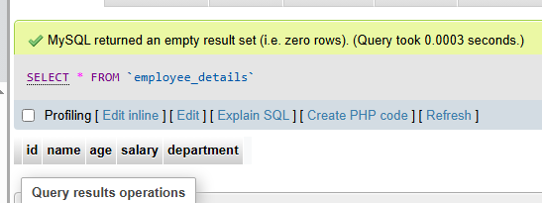

3. Enter values to the tables.
INSERT INTO employee_details
VALUES(1, 'Arun', 25, 30000, 'IT'),(2, 'Priya', 28, 45000, 'HR'),(3, 'Ravi', 24, 35000, 'IT'),(4, 'Anu', 30, 50000, 'Finance'),(5, 'Karthik', 27, 40000, 'Marketing'),(6, 'Divya', 26, 38000, 'Sales'),(7, 'Suresh', 32, 55000, 'Operations'),(8, 'Meena', 29, 42000, 'IT'),(9, 'Vikram', 31, 60000, 'Engineering'),(10, 'Nisha', 23, 32000, 'HR'),(11, 'Manoj', 35, 65000, 'Legal'),(12, 'Kavya', 27, 47000, 'TL'),(13, 'Arjun', 29, 52000, 'IT'),(14, 'Swetha', 25, 36000, 'ComputerService'),(15, 'Rahul', 33, 58000, 'Banking'),(16, 'Pooja', 28, 44000, 'HR'),(17, 'Santhosh', 30, 51000, 'TL'),(18, 'Lakshmi', 24, 34000, 'Finance'),(19, 'Deepak', 36, 70000, 'HR'),
(20, 'Neha', 26, 39000, 'Sales');

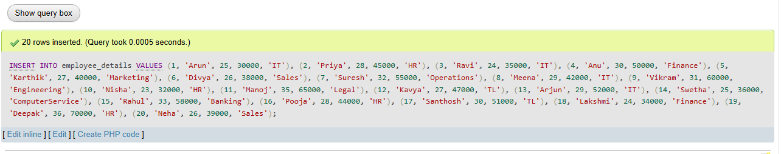Output:
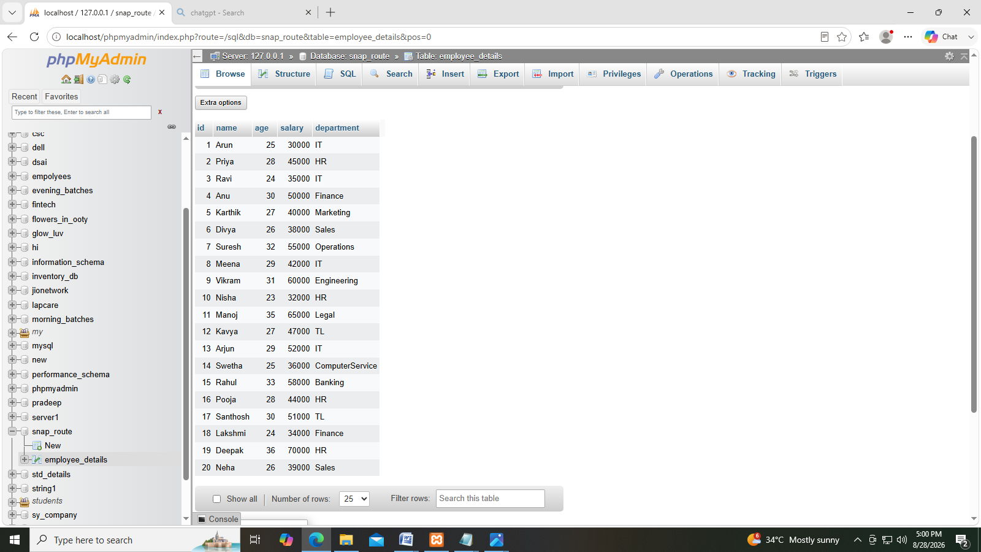

4.use the querys to show data.
Query: 1.select * from employees;
2.select name from employees
3.select name, salary from employees;
4.select name , department from employees;

(1) (2)
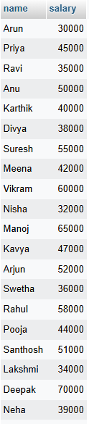
(3) (4)

5. use the query to show data.
Query:1.select name,salary from employee_details here salary>40000;
2. Select name,dept from employee_details where dept=”it”;
3. Select * from employee_details where age<30;
4. Select * from employee_details where salary>35000;
Output:

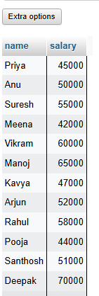
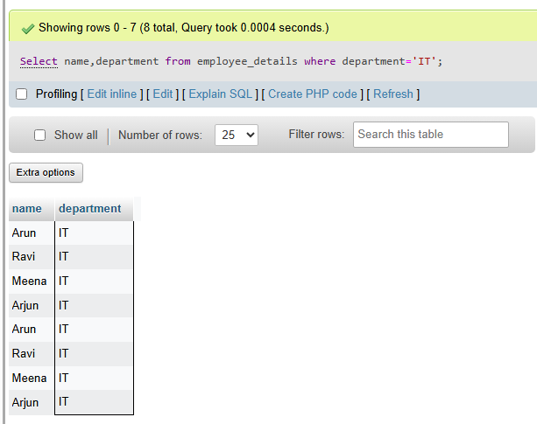

(1) (2)

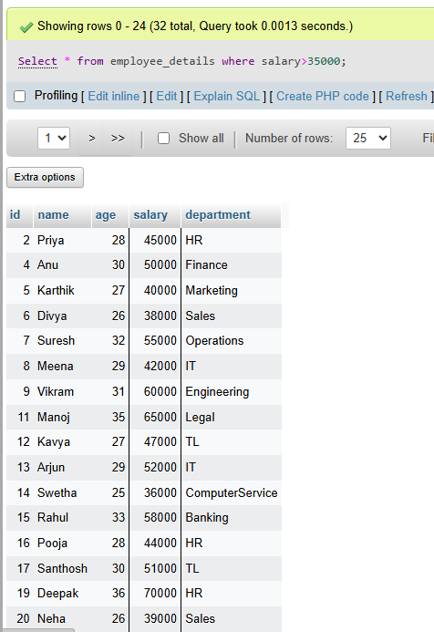
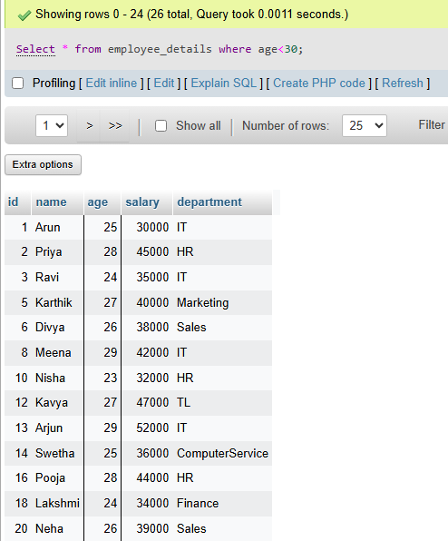
(3) (4)

